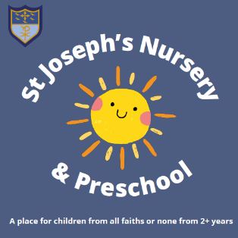

St Joseph’s Catholic Primary School

Early Years Hub – Our Curriculum Rationale

Family
Here at St Joseph’s, our Catholic ethos and the values and virtues we practice as a Catholic community are at the heart of everything we do, ensuring that we are following in the footsteps of Jesus. We aim to create a loving, nurturing environment in which all of our children feel part of our school family . To do this, we take the time to get to know each child and their families so that we can form a strong partnership and adopt a holistic approach to learning, making it personal, meaningful and engaging. We want to embrace diversity and celebrate the different experiences, cultures, talents and skills that all have to offer. We lead by example, with an understanding that respect is a two-way process, remembering to treat others how they would like to be treated.

Communication
Being able to communicate effectively is key and developing this is at the very core of our curriculum. We understand that communication can take different forms and ensure that all children feel valued and understood, whilst constantly facilitating opportunities to nurture and develop these vital skills. We want our children to develop a love of reading and be open to the many possibilities that this can lead to. Taking into account children’s interests, we base our curriculum themes around stories and rhymes to immerse children in new worlds and the rich vocabulary within these. We model and promote active listening, so that children can full engage with all aspects of our curriculum and share their thoughts, experiences and opinions within a safe space.

Independence
We are in a privileged position in our EYFS Hub of being able to see many of our children grow from ‘toddler twos’ to ‘school-ready fives’. The journey within this requires the development of many skills, in which independence arguably underpins them all. Children need to feel confident to take risks in their learning within a safe and nurturing environment in order for them to progress socially, emotionally, physically, spiritually and academically. At Joseph’s, we provide children with opportunities and experiences to gradually develop their independence within an age-appropriate way, which in turn, builds their confidence and helps to set them on a positive cycle of growth and continuous development.

Movement
With advancing technology ever increasing and more and more young children now having access to ‘screen-time’, promoting movement and physical activity is vital within our curriculum. Not only does this promote positive physical health benefits, being active also plays a huge role in developing good mental health and positive well-being. We are lucky to have such fantastic inside and outside spaces at St Joseph’s and aim to use them as effectively as possible. Whether this is dancing, Forest School, jumping in puddles, using climbing equipment, playing ball games, negotiating space on bikes, trikes and scooters or navigating obstacle courses, children will be developing their gross motor skills, including improving their spatial awareness, co-ordination, balance, physical strength and confidence. In turn, this will also have a huge impact on their fine motor skills, equipping them with the skills to be proficient mark-makers and when ready, writers also.

