
St Joseph’s Catholic Primary School
Sycamore Class Homework Grid 2025-2026
Below are optional project-based activities that your child can complete each half term. Please bring it in when completed to showcase to their class at any point in the half term. The children will be rewarded for these projects.
Homework grids will now be provided at the start of the year.
Reading, spellings and times tables should be completed or practised daily.
Please also support your child in filling in their reading record each day.
You can also check your child’s class page on the website for further links to support with homework.

Autumn 1-  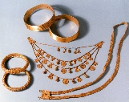  The first half term we are learning all about the Stone, Bronze and Iron Age. The Bronze Age was a time when people started making tools and other things from bronze. Bronze is a metal made from copper and tin. Can you make some ‘Bronze Age’ jewellery? You can use a range of materials e.g., clay, cardboard, newspaper, tinfoil, paint etc. Bring your jewellery in to hang on our topic display! | Spring 1-  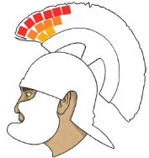  After Christmas, we are learning all about the Romans! Roman mosaics were very popular in homes and public buildings during the Roman Empire. Can you make mosaic art with the Roman soldier. Ask for the template in class. | Summer 1- Two DT projects to choose from.  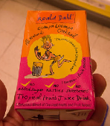  After Easter, we are learning about seasonal food in our country. Can you follow the meatball recipe at home and take pictures? Ask for the recipe.  We will be reading James and the Giant Peach this half term. Can you design and make your own drink based on the book?
Autumn 2-  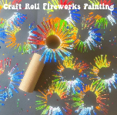  In the second half term, we are learning about different countries around the world, and we are reading ‘The Firework Maker’s Daughter’, influenced by South-East Asian culture. Can you make your own firework art using a toilet roll tube? Look at the picture to help you! | Spring 2-  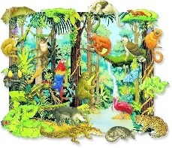  This half term we are learning all about the tropics in the rainforest. Can you remember what each layer of the rainforest is called, and which animals live in each layer? Can you make your own poster with a jungle theme, labelling each layer and illustrating with appropriate animals on each layer. | Summer 2-  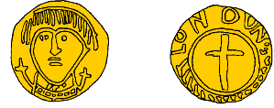  For the last half term, we are learning about the Anglo-Saxons! Design a realistic Anglo-Saxon coin. Use this link to help you get information, ideas and designs: https://www.tha-engliscan-gesithas.org.uk/archaeology-and-important-finds/anglo-saxon-coins/

