
Homework grids will now be provided at the start of the year. Daily practice of the following is very important. Reading should take place each night and be recorded in the yellow reading records. (Roughly 15 minutes per night). Y2 ‘free readers’ will have the opportunity to change their books every week. Number bonds to 10 and 20 Times tables (2, 5 & 10) Spellings (Year 2 -from Autumn 2 Year 1 - from Spring 1),
Please also support your child in filling in their reading record each day.
You can also check your child’s class page on the website for further links to support with homework.
St Joseph’s Catholic Primary School
Oak Class Homework Grid 2025-2026
Below are optional project-based activities that your child can complete each half term. Please bring it in when completed to showcase to their class at any point in the half term. The children will be rewarded for these projects.

Autumn 1-  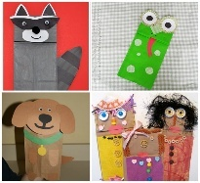  This half term we will be learning about toys from the past. Can you make your own puppet to play with? You could use an old sock, glove a stick or you may have other materials at home that you can use. .What will you call your puppet? What adventures will your puppet have? You can tell us all about it when you show your puppet to the class. | 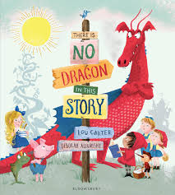  Spring 1- . This half term we are reading ‘There is no dragon in this story’. Design your own dragon by drawing it or making a collage. What will it’s scales and wings look like? What magical powers will it have? Don’t forget to label your dragon. | Summer 1-  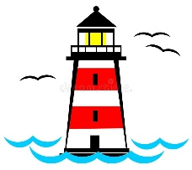  This half term we are reading ‘The lighthouse keeper’s lunch’ and next half term we are learning about Grace Darling. What can you find out about lighthouses? Make or draw your own lighthouse. What colours and features will you choose? Label the important parts of the light house.
Autumn 2- During this half term we will be reading ‘The Snail and the Whale’ by Julia Donaldson  Research either whales or snails.  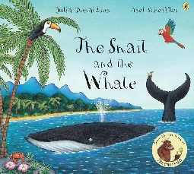  You could draw a picture of one type of whale or snail and write some facts about it, make a collage or model of a whale or a snail or make a poster with information from the internet or non-fiction books. | 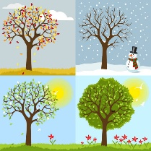  Spring 2- We will be learning about the four seasons this half term.  Which is your favourite season? Spring? Summer? Autumn? Winter? Make an information poster about the season you have chosen. You could include: The months of the year, the weather you would expect, or the clothes you might wear, What activities you might do? What do the trees or nature like? Are there any special celebrations? | Summer 2-  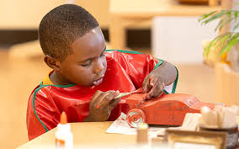    Choose a set of instructions to follow at home. This could be a recipe, craft or instructions to play a new game. Take photos or bring in what you made to show the class that would be wonderful. What made the instructions easy to follow?

